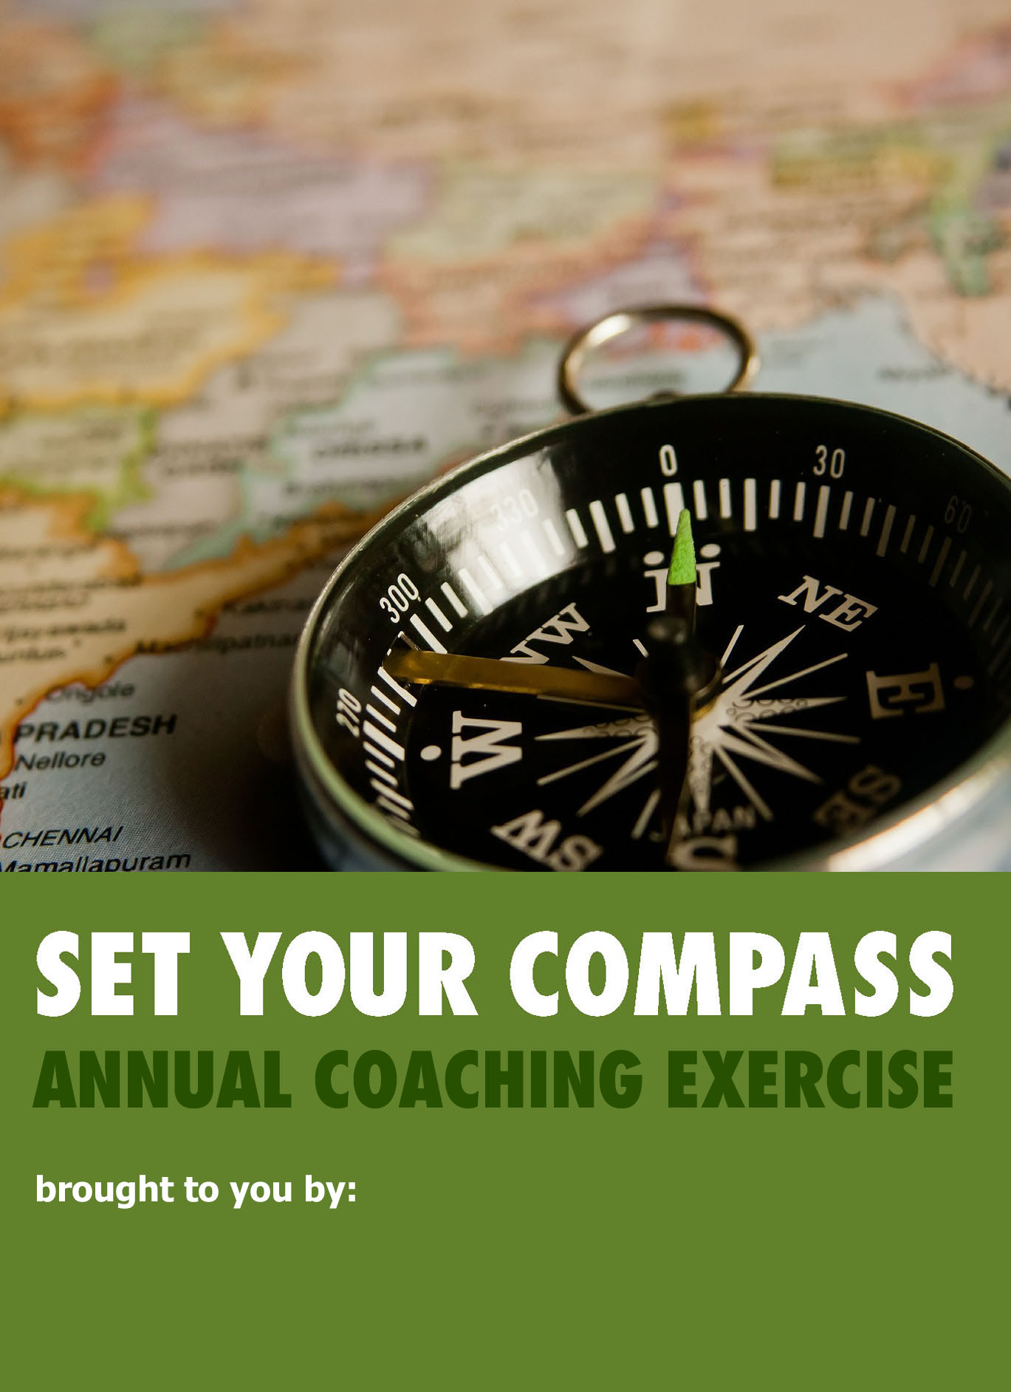

Alquimia Coaching & Development

2023 Review & Highlights

Write below your achievements and learnings in 2023 both personally and in your main role or occupation (whether it's your business, career, parenting or volunteering).

Name Your Top 5 Achievements in 2023  Big, small, what are you MOST proud of?  1. _______________________  2. _______________________  3. _______________________  4. _______________________  5. _______________________ | Name 5 Challenges You Overcame in 2023  What was hard? What did you overcome?  1. _______________________  2. _______________________  3. _______________________  4. _______________________  5. _______________________ | What Did I Learn from my Career / Main Role in Life?  Eg. a skill, aha moment, lesson learned etc.  1. _______________________  2. _______________________  3. _______________________  4. _______________________  5. _______________________
What Did I Learn about Myself?  For example strengths, weaknesses, talents, beliefs, values, hopes, fears etc.  1. _______________________  2. _______________________  3. _______________________  4. _______________________  5. _______________________ | You  in  2023 | What New or Existing Relationships Did I Develop?  Who did you grow your relationship with?  1. _______________________  2. _______________________  3. _______________________  4. _______________________  5. _______________________
What Did I Create or Bring into the World in 2023?  This could be anything at all (big or small!)  1. _______________________  2. _______________________  3. _______________________  4. _______________________  5. _______________________ | How Did I Make a Difference  in the World in 2023?  Big or small, how did you help others/the world?  1. _______________________  2. _______________________  3. _______________________  4. _______________________  5. _______________________ | Where Did I Have the Most Fun?  What did you enjoy most in 2023? This could be anything - at work, home, in life!  1. _______________________  2. _______________________  3. _______________________  4. _______________________  5. _______________________

If you were to write a Newspaper Headline that summarized your 2023, what would it say?

------------------------------------------------------------------------------------------------------------------
2024 Preview & Preparation

Write below what you'd like to learn and achieve in 2024 both personally and professionally.

What Top 5 Things Do  I Want to Achieve in 2024?  Big or small, what would make YOU proud?  1. _______________________  2. _______________________  3. _______________________  4. _______________________  5. _______________________ | Name 5 Challenges You Anticipate in the Year Ahead  What do you expect to be hard/difficult?  1. ________________________  2. ________________________  3. ________________________  4. ________________________  5. ________________________ | What Do I NEED to Learn in the Year Ahead?  What do you NEED in order to grow this year?  1. _______________________  2. _______________________  3. _______________________  4. _______________________  5. _______________________
What Do I WANT to Grow or Learn about Myself this Year?  Where will you stretch and grow yourself?  1. _______________________  2. _______________________  3. _______________________  4. _______________________  5. _______________________ | You  in  2024 | What Relationships Would  I Like To Grow And Develop?  Who inspires, supports & encourages you?  1. _______________________  2. _______________________  3. _______________________  4. _______________________  5. _______________________
What Would I Like to Create or Bring into the World in 2024?  This could be anything at all (big or small!)  1. _______________________  2. _______________________  3. _______________________  4. _______________________  5. _______________________ | How Will I Make a Difference in the World in 2024?  Big or small, how will you help others/the world?  1. ________________________  2. ________________________  3. ________________________  4. ________________________  5. ________________________ | Where Will I Enjoy Myself &  Have Fun in my Life in 2024?  How will you play at work/home/in life?  1. _______________________  2. _______________________  3. _______________________  4. _______________________  5. ________________________

If you were to write a Newspaper Headline that summarized your 2024, what would it say?
____________________________________________________________________________________

EXERCISE INSTRUCTIONS:

- Set aside 30-45 minutes and find somewhere soothing where you can sink into yourself - and this exercise.
- Answer the questions in this exercise to 1) Review and identify your 2023 highlights and 2) Prepare and set the scene for your 2024 goal-setting!

Tip: Do your best to identify the full 5 items for each question - and answer them from the heart. This isn't about what looks good on paper but what you are proud of - however small or unimportant it might seem to others.

NOW CELEBRATE:

- To wrap up this exercise, what reward or treat would remind you that you worked hard, learned and grew as a person? What could you do that would create and anchor a feeling of gratitude and pride in yourself and all you achieved?

Examples could include taking the day off to do something creative or to buy that painting, scarf, tie or jewellery you admire. It could also be something small or symbolic - a lion, an eagle, a chunk of amethyst, a special key-ring. It helps if it is something beautiful you will see often. This isn’t about materialism, but rewarding and celebrating you. Choose something that creates an anchor to remind you of this year, something special to recognize all your efforts.

- Finally, all you have to do is commit to celebrating you: you're worth it!

I hope this fun tool helps you Celebrate YOU
and "Set your Compass" for an Awesome 2024!

"Celebrate what you want to see more of." Thomas J. Peters

